**Results from code:**

80.95% of electrical usage per annum accounted for.

Average cost of electricity bill = €750

Average electricity bill per annum = 4921.26 kWhrs.

Average cost of heating oil (kerosene) = €1600

Average heating oil bill of kerosene = 18509.07 kWhrs.

Total kWhrs per year came in just over the national average of 23,000 kWhrs.

The final figure was 101.87% of 23,000, which is 23430.10 kWhrs per annum.

**Screen shots:**

Top Down Approach:

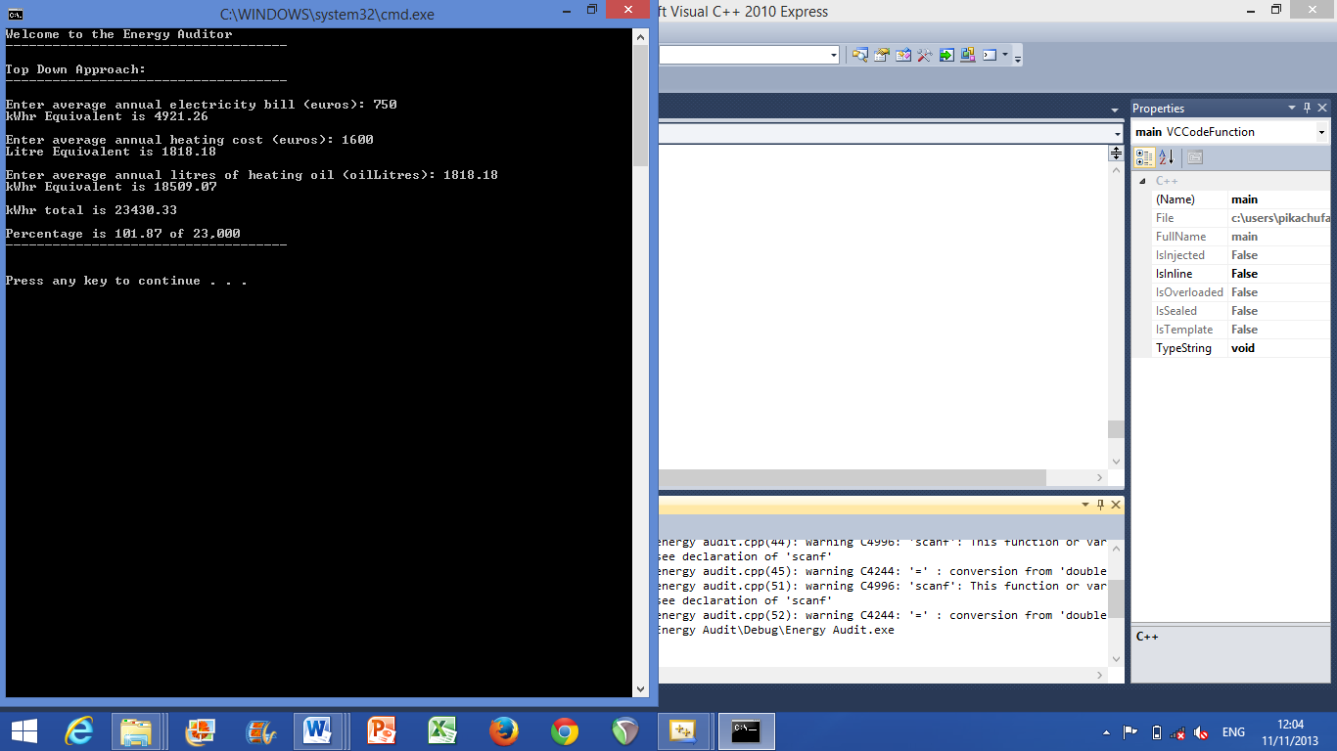

Bottom Up Approach:

